**Frontend Development**

The frontend-layout of the webpage was structured according to **HTML**, **CSS** and **jQuery** technologies

**HTML** stand for **H**yper**T**ext **M**arkup **L**anguage) and it is the dominating building block of the Web. It was created in order to set the structure and content of web pages. Other technologies besides HTML are generally used to describe a web page's appearance/presentation (CSS)

**CSS** stands for **C**ascading **S**tyle **S**heets. CSS saves the trouble of designing the appearance of the website with HTML and defines how HTML elements are to be displayed on screen. CSS can control the layout of multiple web pages all at once and CSS stylesheets are stored in CSS files.

**jQuery**, at its core, is a Document Object Model (DOM) manipulation library. jQuery makes the syntax for finding, selecting, and manipulating these DOM elements simpler. It can be used for finding an element in the document with a certain property, for example, all elements with a certain h2 tag, changing one or more of its attributes such as colour or visibility, or making it respond to an event such as a mouse click.

The customer webpage was designed with very minimal standards. While the original idea was to design a ‘real webpage’, it was decided that the mentality of the design should support a web app that serves only the basic procedure of finding, hiring and returning the bike along with the payment functions.

The final structure of the website was decided to be a Sign Up/ Login webpage.

Initially, the user is introduced to a Welcome page where one can enter their email and password if they are registered users (See Picture 1a)

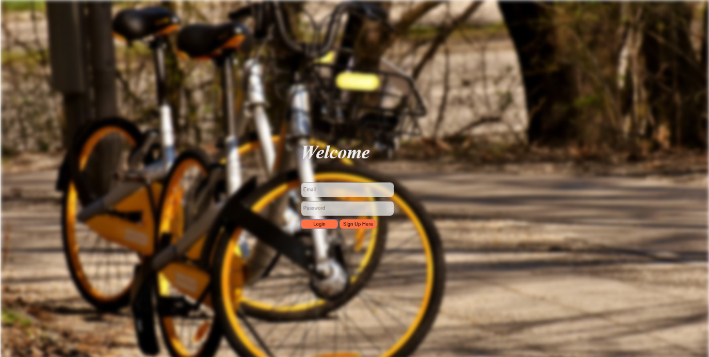

Picture 1a

Or they can login if it is their first time using the webpage (See picture 1b)

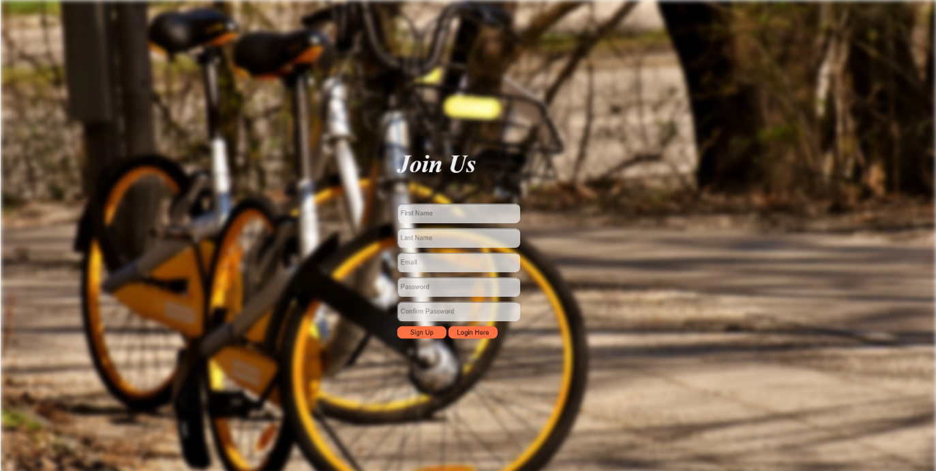

Picture 1b

The rent page displays a map that shows the location of the user and 3 widgets propose to Rent a Bike, to Return a Bike or to Report a Bike. The navbar at the left of the website navigates you to homepage, rent page, profile page or to logout option (See Picture 2)

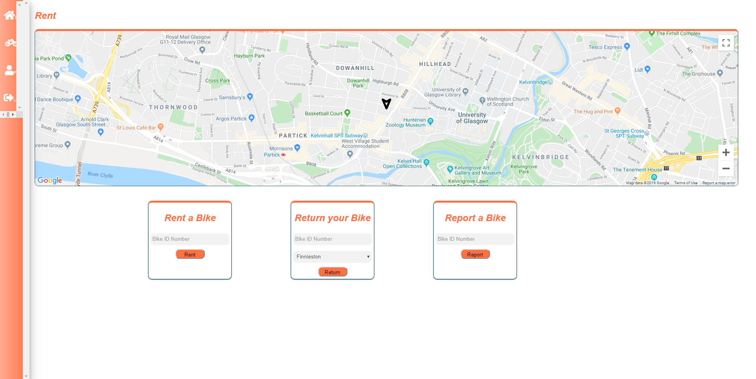

Picture 2

The profile page offers 5 options: to create/ update your profile by entering your personal details, to proceed to payment by entering your bank details, to find out about your account status++++, to close your account by entering your email and, finally, to change your password.

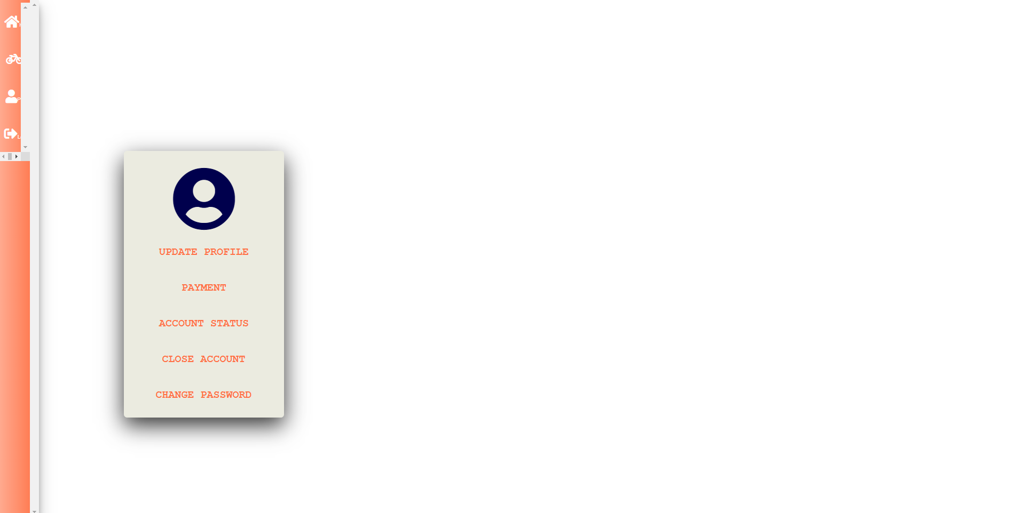

Picture 3

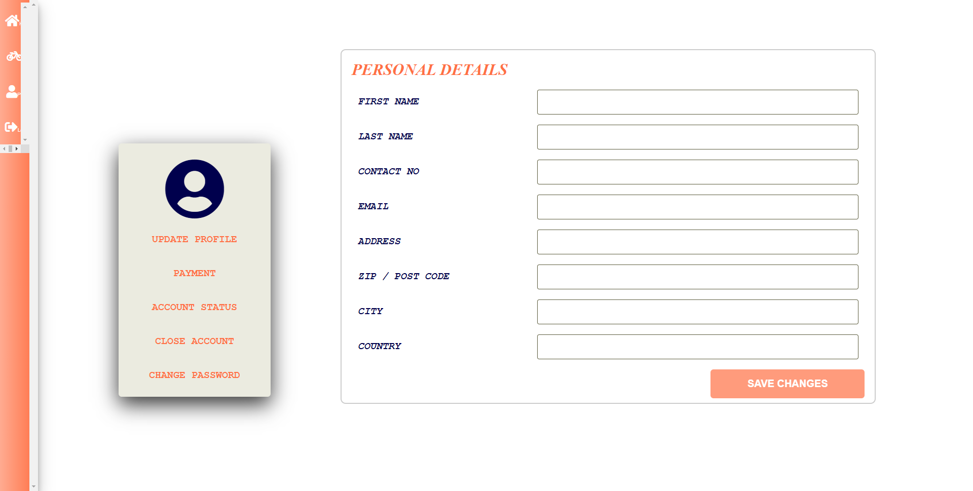

Picture 3a

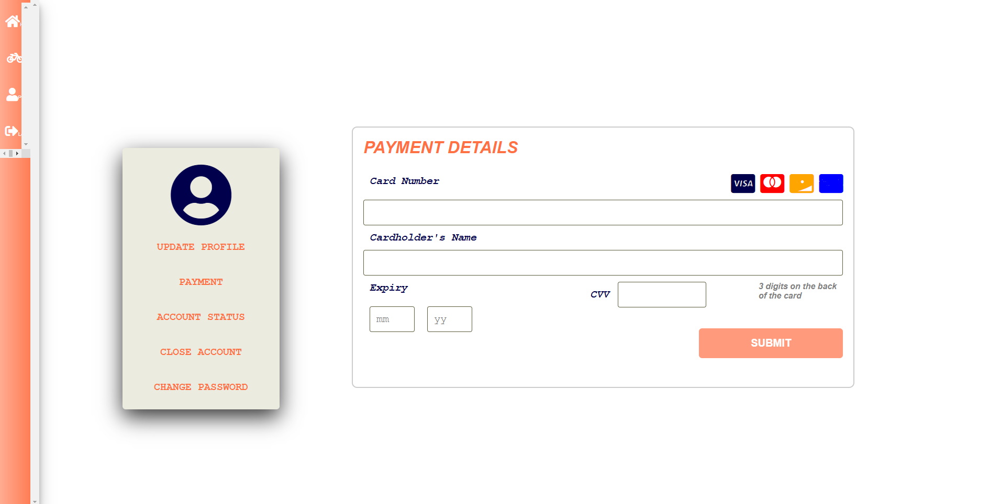

Pictures 3b up and 3c below 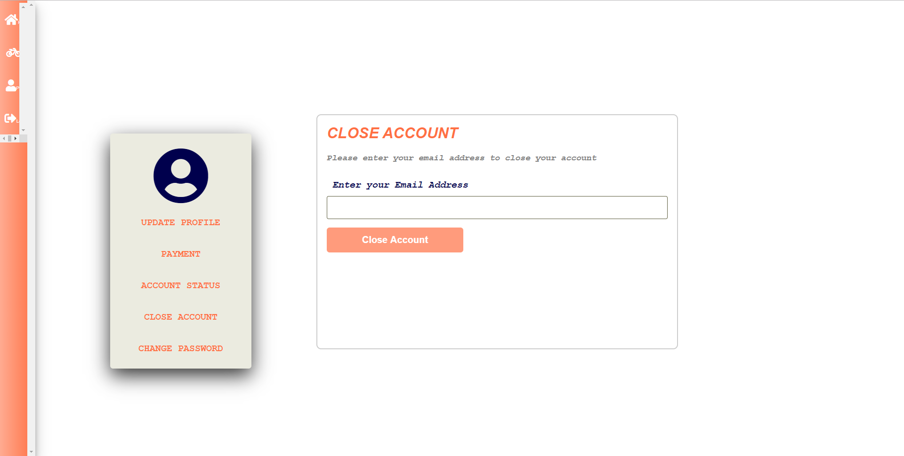

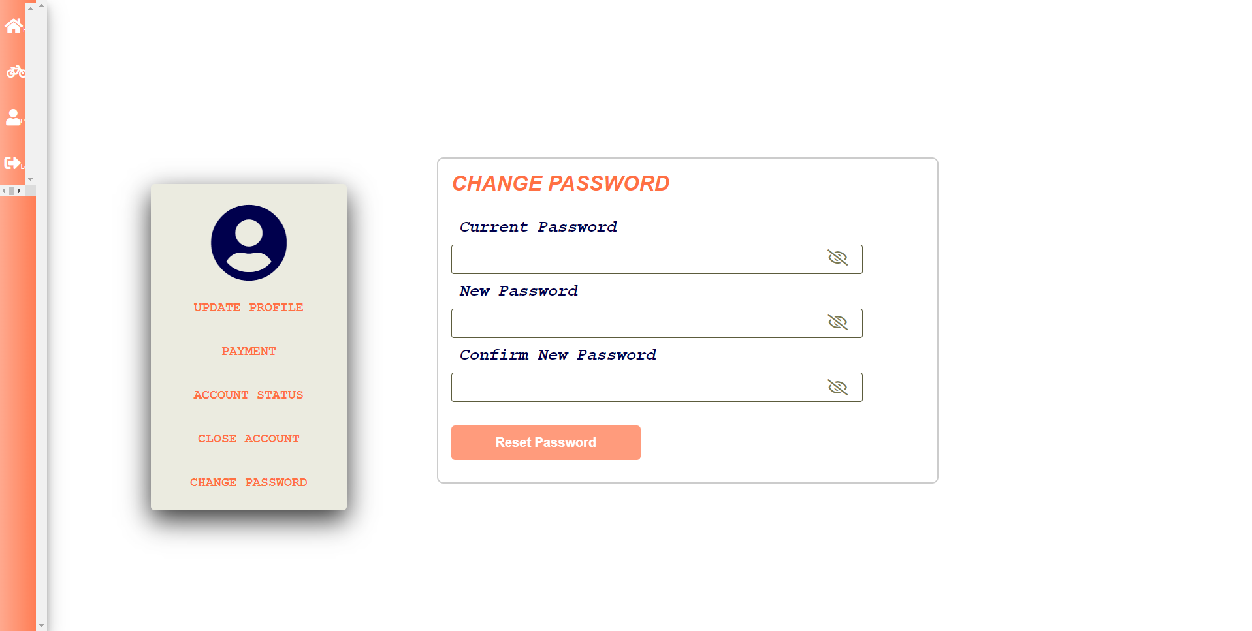

Picture 3d

The main homepage displays 3 widgets: find a bike, to enter code and to return your bike

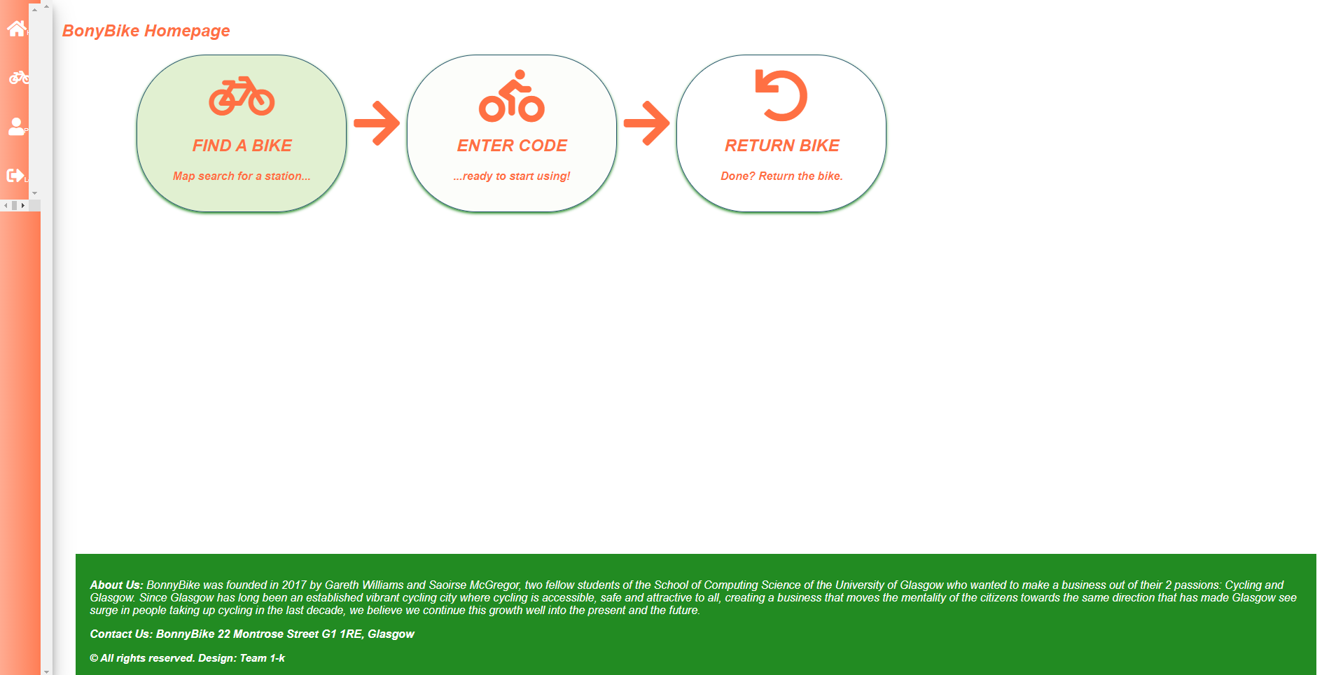

Picture 4